PRESS RELEASE Jan. 23, 2014
Captain Bob’s Historical Treasure Museum
101 Seaway Drive, Fort Pierce, FL 34950-9103
Contact San Miguel Treasure Tours Group at
Email: contact@sanmigueltreasuretours.com
Website: www.sanmigueltreasuretours.com
Or John Vesey, Editor: 561- 308-2841

FOR IMMEDIATE RELEASE

Event: Presentation by Capt. Bob Bouchlas Sr.: The Treasure Ship “1656” that Mel Fisher Never Found: “Maravillas”.

When: February 8, 2014 from 5:00 p.m. to 6:00 p.m.

Where: Capt. Bob’s Place and Historical Treasure Museum, 101 Seaway Drive, Fort Pierce.

The Treasure Ship “1656” that Mel Fisher Never Found: “Maravillas”;
All-New Information Disclosed, Plus Intrinsic Artifacts to be Displayed and Auctioned

Capt. Bob Bouchlas Sr. will speak Saturday, Feb. 8 on The Treasure Ship “1656” that Mel Fisher Never Found: “The Nuestra Señora de las Maravillas”. The presentation will take place from
5 p.m.-6 p.m. at Capt. Bob’s Place and Historical Treasure Museum, 101 Seaway Drive in Fort Pierce.

The event will be free and open to the public, and Capt. Bob’s Famous Oysters will be served complimentary; beer and wine will be available. There will be several intrinsic artifacts on display, including a gold nugget and one of the world’s largest uncut emeralds. An auction of treasure coins that were retrieved before the laws were changed will take place following the presentation. There will be on-premises police protection provided.

The solid gold nugget was on a ship that went down in 1715 and was discovered by Kip Wagner and Gene Chevalier. Capt. Bouchlas also has one of the oldest Shipwreck Cannons in existence, which was on a ship that went down in 1594. There will be an open forum where he will answer questions from the public.

He also plans to discuss the real secret regarding a 1978 Russian Killer Satellite that decayed over the United States and forced then-President Jimmy Carter to be secretly evacuated from Washington, D.C. to Camp David for security and safety reasons. This was discussed in the Palm Beach media for many months, but it wasn’t until one year later when President Carter’s Cabinet member Jay Solomon revealed and corroborated that this was true when he spoke in Palm Beach at the Breaker’s Hotel.

Although there were a great number of newspaper articles on this subject, Capt. Bouchlas still owns all of the copyrights to this story and he has also published a book on the subject, “Great Slave to Jupiter.” This amazing story will also be discussed during Capt. Bouchlas’ Feb. 8th presentation.

Capt. Bob Bouchlas, owner of Capt. Bob’s Place and Historical Treasure Museum, is the original discoverer and began his search for the Spanish Galleon “The Maravillas” in 1975. The Galleon was sunk near Memory Rock in the Bahamas in 1656. Capt. Bouchlas is one of only five living treasure hunters in the Western Hemisphere.

Mel Fisher, who died in 1998, is famous for discovering in 1985 the “Nuestra Señora de Atocha,” which sunk in 1622 near the Florida Keys, and was also one of the treasure hunters who had also been looking for the “Maravillas”.

“When he gave up looking for her, he urged me to keep looking,” Capt. Bouchlas said. “And I did exactly that. I found her in 1975 because I didn’t quit; I kept looking. As a result, I also have two museums – one in West Palm Beach and one in Fort Pierce – devoted to displaying the artifacts from the “Maravillas” and telling its wonderful – yet tragic – story.”

When the “Maravillas” went down in 1656, taking with it more than $2 billion in gold, silver and precious gems, it also had 650 men and women, along with military personnel – many Conquistadors – onboard.

“So, much like the ‘U.S.S. Arizona’, which was bombed in Pearl Harbor and plunged us into World War II, the Nuestra Señora de las Maravillas was a military vessel protecting its contents when it sunk that tragic day in 1656.”

The “Maravillas” also carried – as its secret cargo – a life-size statue of the Madonna and Christ-child, made of gold. The statue is still in its watery vault, waiting to be recovered.

“Yes, the statue is made of gold and I’m sure she is worth many millions of dollars. But to me, she is priceless, because I’m not interested in gold or silver. I’m interested in reuniting Orthodox and Catholic Christianity,” Capt. Bouchlas said. “The statue is priceless because I want the gold statue for one reason, and one reason only. I want to raise her up and return her to where she was going 358 years ago – to the Vatican and then to the Pope in Rome,” he added. “That’s because she was a gift from the King of Spain, King Philip IV to Pope Innocent X to promote World Christian Unity,” he said.

During the Feb. 8th presentation, Capt. Bouchlas intends to tell more of the current story – material that has never before been published or broadcast. “So even those who have attended any of my previous earlier presentations should attend the Feb. 8th presentation,” Capt. Bouchlas said. “They will be pleasantly surprised – along with everybody else – when they learn about the significant events that have happened in recent years.”

That includes the latest information about the federal admiralty laws. “To the best of our knowledge, we are the first to test these laws, and we are doing it with the two sites we have off of Jupiter and Juno, Florida. These two sites are now protected,” Capt. Bouchlas said.

Capt. Bouchlas began his quest to find the “Nuestra Señora de las Maravillas” nearly 40 years ago, and he is still telling the story and hoping to raise up the Golden Madonna and Christ-child statue. “I have new information that I want to disclose about the secret salvage agreements that I retrieved from the Archives in Seville, Spain,” Capt. Bouchlas said.

He added, “This is information that could concern other maritime interests and break new legal ground regarding the Shipwreck Act of 1987 – information that could include England, Spain and the State of Florida. That’s because England owned Florida and parts of the United States when the Spanish ship ‘Nuestra Señora de las Maravillas’ sunk in the Bahamas in 1656, carrying Spanish cargo, as well as salvage frigates of the Maravillas. This predates by 120 years when the colonies won their independence in 1776.”

“So, I hope everybody who is interested in treasure – and the saga of searching for it – will attend this most interesting of presentations on Feb. 8th. I assure you that you won’t be disappointed,” Capt. Bouchlas said.

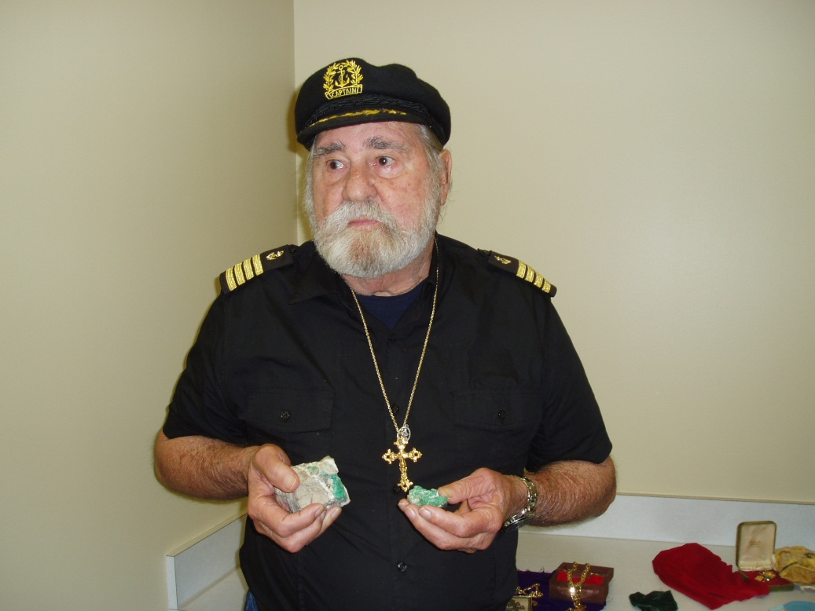
Photo by St. Michael Press Publishing Co., Inc. © 2014

